FHO1000 Hand-held OTDR

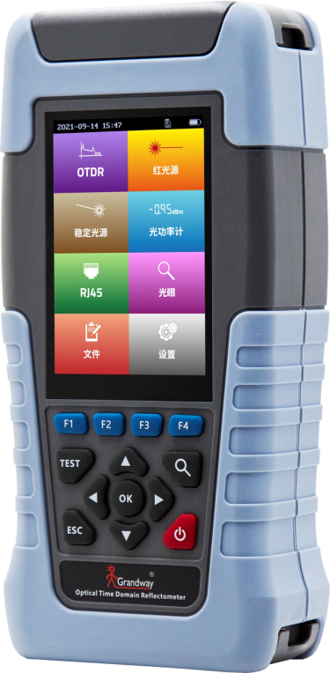
Description：
FHO1000 Handheld OTDR is the latest smart OTDR of Grandway. It can measure the length of optical fiber about 70km. In short distance optical fiber testing, with the excellent 1m/4m deadzone performance, all kinds of continuous connectors, attenuation loss and other events can be clearly distinguished.
FHO1000 is equipped with 1310nm and 1550nm dual wavelength OTDR, optical power meter, stable laser source, 10mw VFL, RJ45 line sequence measurement and other functions. At the same time, it has bluetooth wireless connection (optional) and supports pairing with mobile phones.
Features:
- 3.5 inch(75L x 50mmW ) color LCD, portable design and easy to carry.
- Multi function integration, support 10mw VFL, stable laser source, optical power meter, RJ45 line sequence test and other functions.
- High precision, short deadzone OTDR can accurately test all kinds of continuous connectors and attenuation points in the line.
- 22/20dB dynamic support 70km optical fiber measurement.
- Optional bluetooth connection of mobile phone supports fast transmission of test files to mobile phone.
- Mobile phone remote control, control OTDR test and curve view analysis through the mobile phone.
- IP52 protection level

Specifications:
Items | Specifications
Fiber type | SMF (ITU-T G.652)
Wavelength | 1310±20nm/1550±20nm
Dynamic range | 22/20dB
Test range | 500m,1km, 2km, 5km, 10km, 20km, 40km, 80km
Pulse width | 3ns/5ns/10ns/30ns/50ns/100ns/275ns/500ns/1us/2us/5us/10us/20us
Event deadzone^{①} | ≤1m
Attenuation deadzone^{①} | ≤4m
Refractive index | 1.000~1.999
Sampling points | 64000
Sampling accuracy | 0.05m (1km)
Distance accuracy | ±(1m+test distance×3×10⁻⁵+sampling resolution) (excluding IOR uncertainty)
Loss accuracy | 0.1dB
Linearity | 0.1dB
Reflectance accuracy | ±2dB
Event display | 1) Fiber end  2) Reflection event  3) Splice loss
VFL | Working wavelength: 650±10nm  Output: 10mW, CW/1Hz/2Hz
Stable OLS | Working wavelength: 1310±20nm/1550±20nm  Output >-13dBm, CW/270Hz/1kHz/2kHz
OPM | Calibrated wavelength: 850/1300/1310/1490/1550/1625/1650nm  Test range: -70~+10dBm
RJ45 line sequence test | TIA568-A and TIA568-B standard
Optical interface | OTDR: standard FC/UPC, optional SC/UPC, FC/APC, SC/APC  VFL: 2.5mm universal port  OLS: share the OTDR port  OPM: 2.5mm universal port
Electrical interface | RJ45 port×2, RJ45 remote module  USB Type-C
Wireless | Bluetooth (optional)
Data storage | Pluggable 8GB micro SD card
Battery | 5000mAh lithium battery
Working humidity | 0~85%(non condensing)
Working temperature | -10~50℃
Dimension | 192.9×93.8×47mm
Weight | 0.57kg
Notes：
1, Deadzone test conditions: event deadzone return loss>-45dB, attenuation deadzone return loss >-55dB.
2, The product shell color is optional purple/blue/orange.
- FLM picture:
